A Mysterious Meteor Falls…

As a farmer located in Nowheresville, you don’t have too much excitement outside of the yearly Pumpkin Contest, where the coveted Farmer of the Year award is given to the farmer with the largest pumpkin. One week before the upcoming Farmer’s Market, a meteor falls right into the communal Compost Pile, where all the farmers in the area throw out their unwanted produce for fertilizer.

The next morning, you and your fellow farmers see a very noticeably glowing pumpkin growing out of the mountain of fertilizer. The discarded plants around it are full of life, much more than they were the day before. You must get that plant for yourself, win the competition, and leave your other farmers in the dust!

Materials

X cards *see card index

75 seeds *see index

1 Power Plant

Set-Up Instructions

Separate Power Plant card from the rest of the cards, shuffle deck.

Place the Power Plant in the center of the playspace

Deal 8 cards in a square fashion around the Power Plant. This will serve as the Compost Pile *see How to Play

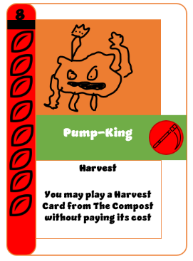



NOTE: This specific layout is not representative of actual play. The 8 cards above will be chosen at random and will not be 8 Pump-Kings.

For each player, deal 5 cards.

The number of seeds given to each player at the start of game varies.

Player 1

4 seeds

Player 2

5 seeds

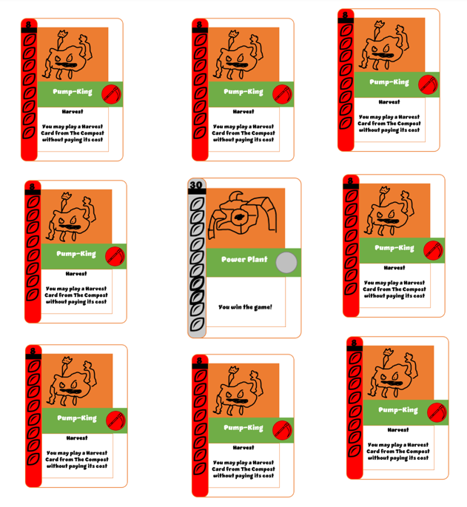

Player(s) 4+

6 seeds

Player 3

6 seeds

The player wearing the most sinister clothing(or with the least amount of colors) goes first.

How to Play

Play proceeds clockwise. Each player will move through a total of four phases per turn:

Reap

Sow

Harvest

End of Turn

Sow

In order to generate seeds, you must have some plants first. You may play up to one plant per turn to your garden, whether it’s from your hand or the compost bin. Spend seeds in order to pay for the plant you want to play. The number you must spend is displayed on the left side of the card.

As you play your plant, place it to the left or right of one of your existing plants. It cannot move from that position unless otherwise specified.

8

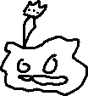

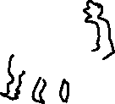

Pump-King

**Harvest**

You may play a Harvest Card from The Compost without paying its cost

If you decide to play a card from the compost bin, you MUST move a card from your hand into the compost bin to replace it. Sharing is caring!

Some of these plants have effects that occur when they come into play., these types of cards have those effects!

This phase ends once you play the maximum number of plants or you decide to pass to the next phase.

Reap

cards! These plants could draw you some cards, deposit some seeds, and much more! When this

as you wish. However,

may be activated only once, unless another card says differently.

These plants flourish over time, so make sure to grab as many of these as you can as early as possible!

Once you’re satisfied, continue onto the next phase.

Harvest

Some plants have adapted to the meteorite a bit differently than the others. plants may be activated once per turn, and any amount within your garden may be activated during this phase. However, the plants aren’t as dedicated to helping your garden flourish, but rather towards stimulating strife and making misery. The plants shake up other players gardens, or, if you’re feeling especially devilish, your own!

After mischief has been managed, begin wrapping up your turn.

End of Turn

After a long day of work, it’s time to wind down. cards rely on what you’ve done during the workday, so make sure you do what they require to acquire their reward.

cards have been activated, discard any excess cards within your hand. The maximum hand size is 7, unless otherwise specified. However, if you have no cards in your hand at this point, draw a card from the draw pile. Additionally, if you have less than 3 seeds, you may gain seeds equal to the difference. After, the turn ends, and play continues clockwise.

Frequently asked questions

“I have multiple card effects; how do I know which one to resolve first?”

Farmer’s choice! It’s up to the current player to decide what card resolves first.

“This card doesn’t have an icon, what does it do?”

Cards without icons are a continuous effect, if they have an effect at all. For example, (card) says (You have a max hand size of 10). Therefore, you ALWAYS have a maximum hand size of 10, at least as long as you have that plant in your garden.

“I forgot to activate one of my effects last phase, can I go back and do that effect now?”

That decision relies on the agreement of all players at the table. If at least one player votes against this, then you may not activate that effect.

“I really want one of my plants to be next to another plant, but I’ve already played it; can I just slide a few of my cards around to make it work?”

Just like planting real plants, once they’re in the dirt, they’re stuck. However, there are a few cards that allow you to swap cards around, so with a bit of gumption and time, you may be able to get that card in the spot you want!

Winning the game

A player wins the game once purchase the Power Plant. After this point, the game is over.

If there are remaining players who wish to continue, remove the Power Plant from the winning player’s garden and place it back into its spot in the compost pile. Leave all other plants within the winning player’s garden. Play then continues, skipping over the winning player. The next winner wins the game once they purchase the Power Plant.

Play Example

// need cards to be done-ish in order to complete. will go through one player’s round (focus on sow and harvest), then next player’s round (using mainly harvest and end of turn plants) .

Index

// all cards go in here. try to make them fit 3 <-> per row